**Project Initialization and Planning Phase**

| Date | 10 June 2025 |
| --- | --- |
| Team ID | x |
| Project Name |  |
| Maximum Marks | 3 Marks |

**Problem Statements:**

**Scenario 1: Smart Grid Implementation in Urban Areas - Problem Statement (PS-1)**

As a city resident or municipal official, I am trying to ensure sustainable and efficient energy consumption in a rapidly growing urban environment. However, traditional power grids are outdated, inefficient, and not equipped to support the integration of renewable energy sources. This is primarily due to a lack of real-time data systems and smart infrastructure for intelligent energy management. As a result, I feel frustrated by energy waste, increasing costs, and the negative impact on the environment.

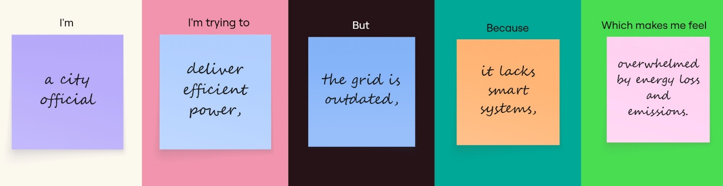

|  |  |  |  |  |  |
| --- | --- | --- | --- | --- | --- |
| **Problem**  **Statement (PS)** | **I am**  **(Customer)** | **I’m trying to** | **But** | **Because** | **Which makes me feel** |
| PS-1 | a city official | deliver efficient power, | the grid is outdated, | it lacks smart systems | overwhelmed by energy loss and emissions. |

**Scenario 2: Industrial Energy Management in Manufacturing Plants – Problem Statement (PS-2)**

I am a manufacturing plant manager responsible for operations and energy-related costs. My goal is to reduce energy consumption and operational expenses while maintaining high production efficiency. Unfortunately, I lack the real-time visibility and advanced tools needed for predictive optimization. This is because the current systems are outdated and not integrated with modern data analytics or renewable energy solutions. This makes me feel pressured to meet sustainability targets without compromising the plant’s performance or profitability.

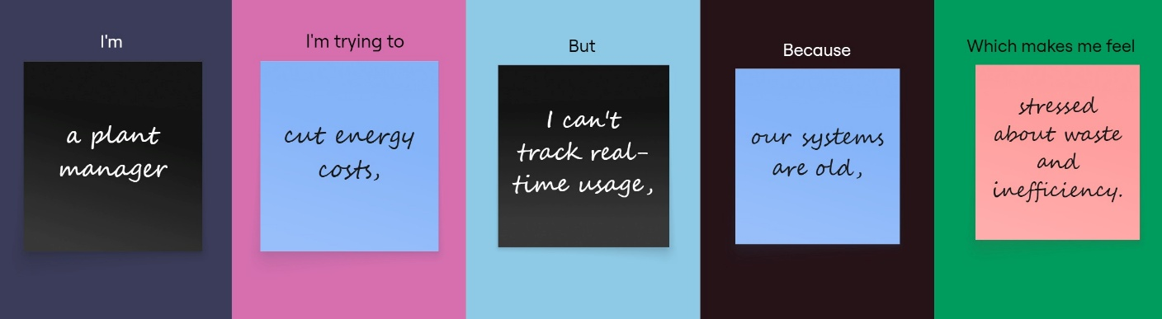

|  |  |  |  |  |  |
| --- | --- | --- | --- | --- | --- |
| **Problem**  **Statement (PS)** | **I am** | **I’m trying to** | **But** | **Because** | **Which makes me feel** |
| PS-2 | a plant manager | cut energy costs, | I can’t track real-time usage, | our systems are old, | stressed about waste and inefficiency. |

**Scenario 3: Rural Electrification in Developing Countries – Problem Statement (PS-3)**

As a rural community member or an NGO working in off-grid areas, I am trying to gain access to reliable and affordable electricity to improve basic living conditions. But our region lacks power infrastructure, and existing diesel-based alternatives are costly and unsustainable. This is because remote communities are often overlooked in national energy initiatives and receive limited investment. Consequently, I feel marginalized and deprived of access to education, healthcare, and opportunities for economic advancement.

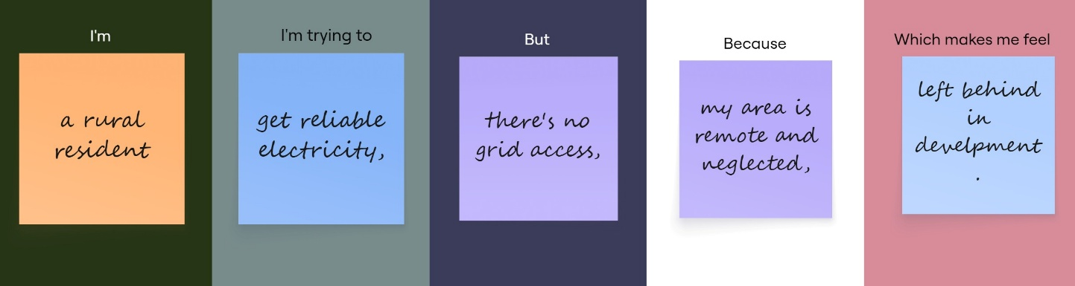

|  |  |  |  |  |  |
| --- | --- | --- | --- | --- | --- |
| **Problem**  **Statement (PS)** | **I am** | **I’m trying to** | **But** | **Because** | **Which makes me feel** |
| PS-3 | a rural resident | get reliable electricity, | there’s no grid access, | my area is remote and neglected, | left behind in development. |